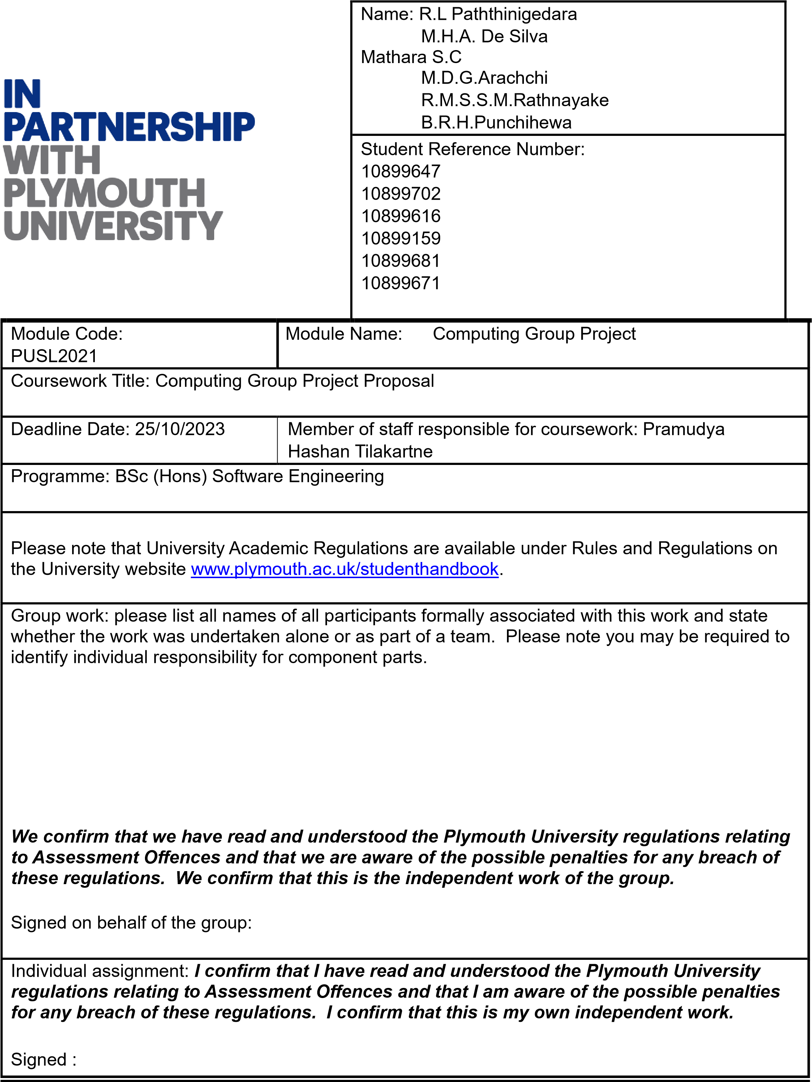

Use of translation software: failure to declare that translation software or a similar writing aid has been used will be treated as an assessment offence.

I *have used/not used translation software.

If used, please state name of software…………………………………………………………………

**Overall mark _____% Assessors Initials ______ Date_________**

*Please delete as appropriateSci/ps/d:/students/cwkfrontcover/2013/14

Project proposal

# Introduction

The railway travel system in Sri Lanka is characterized by various delays in purchasing tickets at the station and busy and long queues at various times. Because of these long queues passengers miss there trains always. Thankfully, a technological breakthrough in the form of the "Train Ticketing" system has revolutionized the experience for travelers around the world.

Seat reservations and ticketing have never been easier and more efficient with this solution. Restructuring of the current system to combat long lines at stations is a must currently. Due to the economic instability in Sri Lanka, many passengers use this train for their travel activities. Reasonable prices and quick travel can be stated as the reasons for this practice. Providing a smoother and more satisfying train travel experience.

The “Train Ticketing” system is a revolutionary solution to the outdated system and caters to all categories – domestic and international passengers, especially those on local routes. It is efficient, comfortable, and improves the quality of your daily commutes. Also, this arrangement can be attributed to the ability of mostly elderly citizens to easily buy tickets at the train station window. Because it happens. Thanks to "Train Ticketing", long queues during peak hours, for example 6-8 AM and 4-6 PM, and some glitches associated with manual issuance of tickets at the station window are now in place with this new system we are introducing.

Unquestionably a tried-and-true procedure, this all-inclusive rail travel solution gives customers a hassle-free option to buy tickets and reserve seats. The service is always available and from any location. Although traditional ticket purchase is still possible for those who prefer it.

Flexibility is key with this system as it allows passengers to choose between 1-5 seats while booking train tickets. "Train ticketing." This convenient service goes beyond buying and booking train tickets. It offers a method to make rail travel simpler using QR codes. A QR code that will simplify boarding the train will be provided to you after your ticket is purchased. Passengers can quickly board the train on time by scanning the QR code, guaranteeing a more productive travel.

# objectives

The objective of this project is to provide a ticketing and seat reservation system that ensures timely arrival of train passengers to their trains and control long queues at ticket counters at railway stations.

1. Accessibility:

Inclusion of train travel for a wide range of passengers by providing multi-lingual support and userfriendly features, thereby enabling a passenger of any literacy level to easily get their tickets.

1. User Participation:

Create an environment that helps create a sense of harmony and cooperation among passengers. By doing this they can easily give feedback and share their views, thus making the entire train journey experience pleasant.

1. Continuous Improvement:

We strive to improve the user experience by updating and improving based on passenger feedback.

Why we implement this solution.

We always provide the greatest experience for our users. We continually enhance our services based on customer feedback to do this.

The purpose of introducing the "Railway Tickets" solution is to solve the problems in the ticketing system in Sri Lanka. Existing problems like long queues and missed train services have made passengers uncomfortable.

Our objective is to make purchasing tickets easier and to give customers a simple way to reserve seats on trains. Long lines at train stations are becoming a major worry for both local and international travelers, and the current system needs to be drastically changed. "Train Ticketing" is designed to significantly enhance the daily commuting experience by providing a reliable and convenient, efficient means of booking train tickets and seats. It not only focuses on long distance trains but also covers the entire range of train journeys including short distances.

Especially we are designing this project for short distance trains. The reason is that there is already a functioning system for long distances and those ticket windows. Queues are not as long as in front of short distance train ticket windows. To address these issues and further enhance the passenger rail travel experience, this project's goal is in line with them. The main goals are to do away with long lines, lessen mistakes caused by manual ticketing, and offer a straightforward and flexible system that enables users to easily purchase tickets from their mobile devices.

Additionally, greatly assisting in streamlining the boarding process and boosting security is the use of QR codes. "Train Ticketing" project seeks to improve, facilitate, and secure rail travel in Sri Lanka. By improving the system depending on their needs, it hopes to foster a sense of community among the users.

Who stands to gain?

1. People who frequently travel within Sri Lanka:

This software makes it easier for people who frequently travel by train to purchase train tickets.

1. Tourists:

This user-friendly program enables visitors to Sri Lanka to easily traverse the country's train system, regardless of their level of familiarity with the local tongue.

1. Train Managers:

"Railway Tickets" offers a web app for effectively managing tickets and train information, which contributes to the smooth operation of the railway system.

1. Travelling families:

If you need to book numerous tickets since you're travelling with your family, you can do it using this app.

# App Features

1. Support for Multiple Languages:

The app available in Sinhala, Tamil, and English languages so any person can use it easily.

1. Notifications alerts:

Receive real-time alerts regarding delays, cancellations, and critical travel information to ensure a smooth trip.

1. Secure Payments:

Tickets can be purchased securely using a variety of payment methods such as credit cards and online banking.

1. Offline Access: you can access your ticket if needed even when you are offline, so you always have your travel information.
2. Simplicity:

The software offers a basic and user-friendly interface, making it simple to use.

1. User Feedback:

Your recommendations are valuable, and the software is updated and improved depending on your feedback.

1. Emergency Help:

If you require assistance or wish to report an incident, you can use this tool to ensure a safe travel experience.

# Time frame

